
Name: Ali Raza
Reg no: 9864
Subject: DBMS
Submitted To: Sir Zohaib Khan

Lab no 05

Q1. Create a table called EMP with the following structure.
Code:
SQL> CREATE TABLE emp (
2 empno NUMBER(6),
3 ename VARCHAR2(20) NOT NULL,
4 job VARCHAR2(10) NOT NULL,
5 deptno NUMBER(3),
6 sal NUMBER(7,2),
7 CONSTRAINT emp_empno_pk PRIMARY KEY (empno)
8 );
Output:
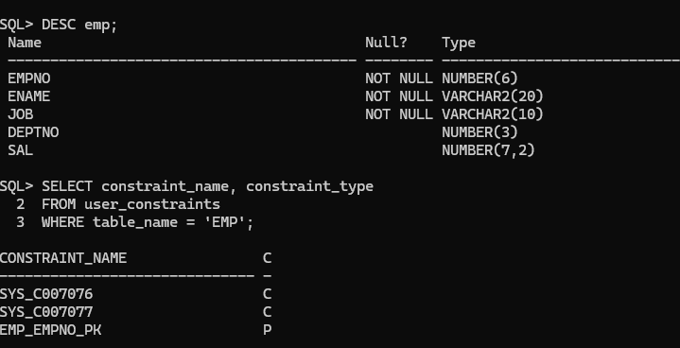

Q2: Add a column experience to the emp table. Experience numeric null allowed.

Code:
ALTER TABLE emp ADD (experience NUMBER(2));

Output:
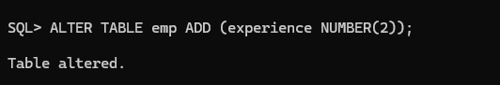

Q3: Modify the column width of the job field of emp table.

Code:
ALTER TABLE emp MODIFY (job VARCHAR2(13));

Output:
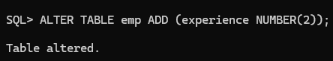
Q4: Create department table with the following structure.
Code:
CREATE TABLE department (
deptno NUMBER(2),
dname VARCHAR2(10),
loc VARCHAR2(10),
CONSTRAINT department_deptno_pk PRIMARY KEY (deptno)
);
Output:
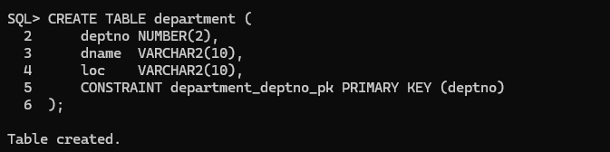
DROP TABLE department;
Output:
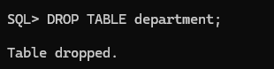
SELECT constraint_name, constraint_type
FROM user_constraints
WHERE table_name = 'DEPARTMENT';
Output:
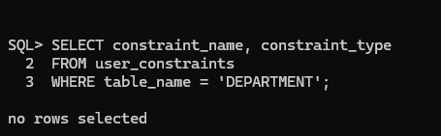
Q5. Create a table called staff with the following structure.
Code:
CREATE TABLE staff (
empno NUMBER(6),
ename VARCHAR2(20),
job VARCHAR2(10),
deptno NUMBER(3),
sal NUMBER(7,2),
CONSTRAINT staff_empno_pk PRIMARY KEY (empno),
CONSTRAINT staff_deptno_fk FOREIGN KEY (deptno)
REFERENCES department (deptno)
);
Q6: create the emp1 table with ename and empno, add constraints to check the
empno value while entering (i.e) empno &gt; 100.
Code:
CREATE TABLE emp1 (
ename VARCHAR2(10),
empno NUMBER(6),
CONSTRAINT emp1_empno_ck CHECK (empno > 100)
);
Output:
